**Object-Oriented Application Development**

**Practical 10**

1. Create a Windows application with an interface containing 2 text boxes, to allow a user to input a first name and a last name, and a button. When the button is clicked, the names are to be displayed in a message box with one space between the first name and last name.

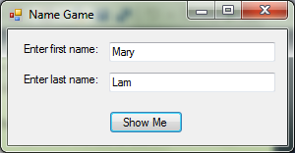 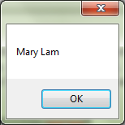

btnShow

tbxLName

tbxFName

1. Create a Windows application with an interface containing a text box, to allow a user to enter some words, and a button. When the button is clicked, the application displays the text in the same text box with all the letters in uppercase. But if the text box is empty when the user clicks the button, the application displays an error message in a message box instead.

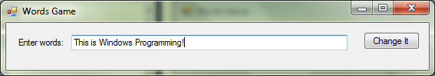

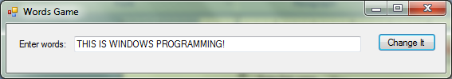

1. Create a Windows application with an interface containing 2 text boxes, for a user to enter an e-mail address two times, and 2 buttons. When the first button is clicked, the application checks that the email addresses are the same and displays a message accordingly in a message box. When the second button is clicked, the application clears the text boxes, i.e. sets to empty string (“”).

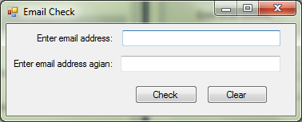

1. Create a Windows application that has 2 text boxes and 2 buttons but initially only first text box and button is enabled. If the user enters ‘UTAR’ in the first text box and clicks the first button, then second text box and button become enabled. After the user enters a name and clicks on the second button, the application displays ‘Welcome’ followed by the name in a message box.

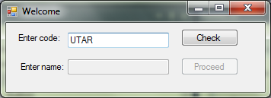

btnProceed

btnCheck

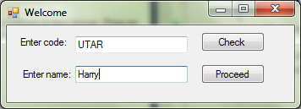

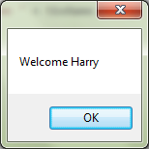

1. Modify the Windows application in Question 6. When the form first loads, only the first label, text box, and button are visible. After the user enters ‘UTAR’ in the first text box and clicks the first button, the second label, text box, and button become visible. To do this, use the Visible property instead of the Enabled property.
2. Create a Windows application that has a text box, a button, and 3 labels as shown below with sample input and output. After the user enters some text in the textbox and clicks the button, the application displays the result in the third label.

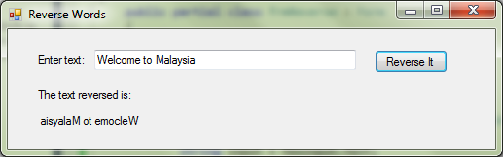

third label

second label

first label